**Topic:** The Great Theorem, Newton’s Approximation of

**Notes on Topic:**

Newton starts with a circle with the center on a graph at, (½, 0)

He knew the circle’s equation was,

Simplifying and solving for y gives the equation of the upper semi-circle as,

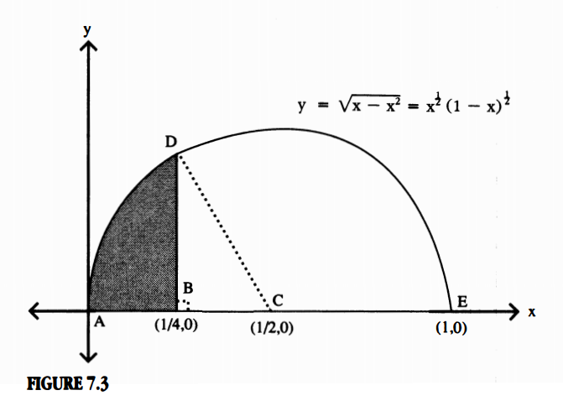

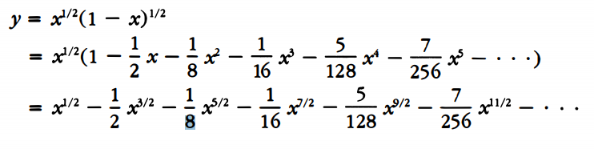

Newton then let B be the point (¼ , 0) and drew BD perpendicular to the semi-circles diameter AE. He then attacked the area ABD in two very different ways.

**Part 1: Area ABD by fluxions:**

Newton was able to find the area under the curve starting at 0 and working rightward to x=¼

By rule 1 and 2 of *De Analysi* the shaded area was just,

…

… = (**)

Then evaluating the above expression using x= ¼ shows us the genius of Newton, and why he made the choices he did, it simplifies beautifully to,

and and so on …

Then, by approximating the series (**) by the first nine terms, we get the shaded area under the curve (ie. ABD) is,

= 0.07677310678

**Part 2: Area ABD by geometry:**

Then, Newton re-examined the problem of the shaded area

First he determined the area of the right triangle . Note, the length of BC is ¼ while CD, being a radius is ½ . Directly applying the pythagorean theorem yields,

Hence,

Then, Newton wanted to determine the area of the wedge ACD. With the length of BC being exactly half of the hypotenuse CD, he recognized that this is a special 30-60-90 triangle, and in particular <BCD was 60 degrees.

By his specific placement of point B, Newton had the insight to see that he would be creating a 60 degree angle, which is ⅓ of the angle forming the semi-circle (180 degrees). Therefore the area of the sector was likewise ⅓ the area of the semi-circle.

Area (sector) = ⅓ Area (semi-circle) =

Thus, the geometric approach to the shaded area yields,

Area (ABD) = Area (sector) - Area (=

Equating this value with the value we received from approximating the same shaded area with the fluxions method and solving for gives us the estimate,

**Q.E.D**

The amazing thing about this estimate is that with just nine terms of the binomial expansion, Newton was able to correctly approximate the first seven digits of .

This result clearly demonstrated the efficacy of his new mathematical discoveries in addressing an old problem with remarkable success.

This approximation was taken directly from Newton’s *Methodus Fluxionum et Serierum Infinitarum,* a 1671 treatise, left unpublished for decades. In the treatise he expands on the fluxion ideas of *De Analysi* and expands the approximation of out 16 decimal places based on a 20 term expansion of .

One point commenting, “I am ashamed to tell you to how many places of figures I carried these computations, having no other business at the time.”

**Additional Suggested Reading**: Epilogue, Chapter 7

**Assignment:** Homework 6 Problems 95, 96(EC), 97, 98